**MAULANA AZAD NATIONAL INSTITUTE OF TECHNOLOGY BHOPAL**

**DEPARTMENT OF CSE**

Name: Yashwant Patidar

Scholar Number: 191112243

Section: CSE 2

3rd SEM BTech

Subject: Principles of Programming Languages Lab - CSE 219

**Lab Assignment**

**Question 1:** WAP to create two classes named A and B, create another class named C which inherits both class A and B. Now, create a function in each of these classes which prints “A-class”, “B-class” and “both-class A and B” respectively. Now create an object for each class. Call the function of each of its parent by the object of class C.

**Program code:**

#include<iostream>

using namespace std;

class A{

public:

    void print(){ cout<<"A-class"<<endl;}

};

class B{

public:

    void print(){ cout<<"B-class"<<endl;}

};

class C: public A, public B{

public:

    void print(){ cout<<"both-class:A and B"<<endl;}

};

int main(){

    A a;

    B b;

    C c;

    a.print();

    b.print();

    c.print();

    c.A::print();

    c.B::print();

    c.print();

}

**Output:**

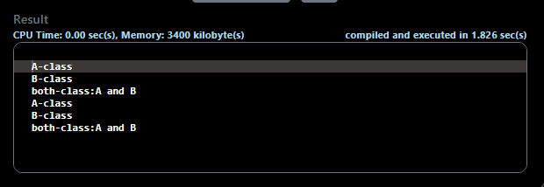

**Question 2:** WAP to read and display information about employees and managers. Emp is a class that contains emp_no, name, address and department. Manager class contains all information of the Emp class and a list of employees working under a manager.

**Program Code:**

#include<iostream>

#include<string>

using namespace std;

class Emp{

protected:

    int emp_no;

    string name, address, dept;

public:

    void getInfo(){

        cout<<"Enter employee number: ";

        cin>>emp_no;

        cout<<"Enter employee name: ";

        getline(cin.ignore(), name);

        cout<<"Enter employee address: ";

        getline(cin, address);

        cout<<"Enter employee department: ";

        getline(cin, dept);

    }

    void display(){

        cout<<"Employee Number:"<<emp_no<<endl;

        cout<<"Name:\t\t"<<name<<endl;

        cout<<"Address:\t"<<address<<endl;

        cout<<"Department:\t"<<dept<<endl;

    }

};

class Manager:public Emp{

    int size;

    Emp* Employees;

public:

    void getInfo(){

        cout<<"Enter name of manager: ";

        getline(cin, name);

        cout<<"Enter Manager Address: ";

        getline(cin, address);

        cout<<"Enter Manager Department: ";

        getline(cin, dept);

        cout<<"Enter number of employees under him: ";

        cin>>size;

        Employees = new Emp[size];

        for(int i=0;i<size;i++){

            cout<<"\nEnter details of employee "<<i+1<<endl;

            Employees[i].getInfo();

        }

    }

    void display(){

        cout<<"\nManager: "<<name<<endl;

        cout<<"Manager's address: "<<address<<endl;

        cout<<"Managers's department: "<<dept<<endl;

        cout<<"The list of "<<size<<" employees under the manager:"<<endl;

        for(int i=0;i<size;i++){

            Employees[i].display();

            cout<<endl;

        }

    }

};

int main(){

    Manager M;

    M.getInfo();

    M.display();

}

**Output:**

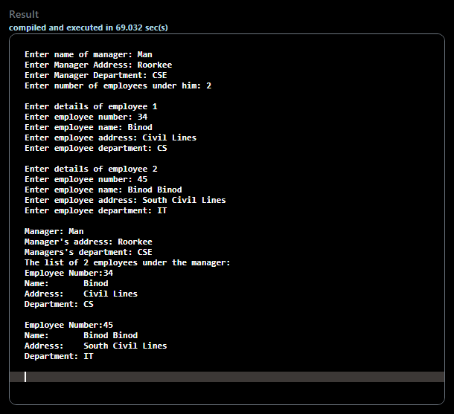

**Question 3:** WAP to print the factorial of a number given by user by creating a class Factorial. If no number is passed by the user while creating an object of factorial class, then the number should be 0, using constructor overloading.

**Problem Code:**

#include<iostream>

#include<string>

using namespace std;

class Factorial{

    int num;

    int fact(int n){

        return n <= 1 ? 1 : fact(n-1)*n;

    }

public:

    Factorial(int n){num=n;}

    Factorial(){num=0;}

    int calc(){return fact(num);}

};

int main(){

    Factorial F1, F2(6);

    cout<<"Factorial by not passing any argument: "<<F1.calc()<<endl;

    cout<<"Factorial by passing 6: "<<F2.calc()<<endl;

}

**Output:**

